**Week 05**

- Andrade, Mosiah Assunção

- Bass, Aldana Valentina

- Amachi, Cristofer Miguel

1. **Question**
   1. Inquiry of Orders from Santa Cruz Bikes Store in January 2016
   2. Andrade, Mosiah Assunção
   3. **SELECT** cust_order_id, order_date, shipped_date, store_name, first_name

**FROM** cust_order co

**JOIN** store s

**ON** co.store_id = s.store_id

**JOIN** customer c

**ON** co.customer_id = c.customer_id

**WHERE** store_name = "Santa Cruz Bikes" **AND** shipped_date **IS**  **NOT NULL AND** shipped_date **LIKE** "2016-01%"

**ORDER BY** first_name;

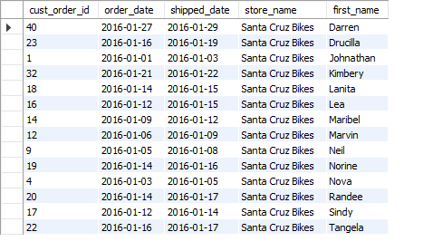

1. **Question**
2. I want to show the customer's first and last name and how many products they have ordered in total
3. Bass, Aldana Valentina
4. SQL query used to answer the questions:

SELECT c.first_name, c.last_name, COUNT(p.product_id) AS total_products

FROM customer c

JOIN cust_order_item oi ON c.customer_id = oi.cust_order_id

JOIN product p ON oi.product_id = p.product_id

GROUP BY c.first_name, c.last_name;

1. Query results, either as a screen shot or table

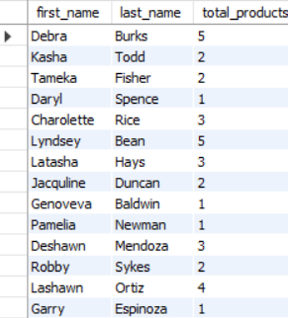

1. **Question**
2. The question being answered: I need to know the name of the artist and the name of the artwork of art with the keyword of the artwork "water".
3. Team member name that lead the discussion: Bass Aldana Valentina
4. SQL query used to answer the questions:

SELECT a.fname, aw.title, keyword

FROM artist a

JOIN artwork aw ON a.artist_id = aw.artist_id

JOIN artwork_keyword ak ON aw.artwork_id = ak.artwork_id

JOIN keyword k ON ak.keyword_id = k.keyword_id

WHERE k.keyword = 'water';

1. Query results, either as a screen shot or table

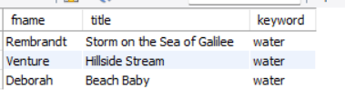

1. **Question**

* In the bike DB, what are the full names of all employees and in what store do they work?
* Cristofer Amachi Cervantes.
* “””
* USE bike;
* SELECT first_name, last_name, store_name
* FROM staff sf
* JOIN store st
* ON st.store_id = sf.store_id;
* “””
* 